COVID-19 Communication and Preparation Tools for Hospitals and Health Systems (Updated April 13, 2020)

The United States and Michigan are experiencing a growing outbreak of coronavirus, or COVID-19, which is having a direct impact on Michigan’s healthcare providers and vulnerable patients. The MHA is in regular contact with the Michigan Department of Health and Human Services (MDHHS), elected officials and others regarding Michigan’s preparedness and response. The following tools are intended to help hospitals effectively and accurately communicate with and prepare their patients, staff and communities using guidance from infection control experts at the state and national level.

The MHA encourages hospitals to follow guidance from the Centers for Disease Control and Prevention (CDC) and the Occupational Safety and Health Administration (OSHA), linked on the MHA’s dedicated COVID-19 website, for clinical and safety best practices and employment guidelines.
Contents
Key Messages for Public Inquiries: 2
Sample Social Media/Affinity Group Posts 4
Frequently Asked Questions: 10
Health System Compartment Hardening for COVID-19 12

Stay in Touch:
- Follow the MHA website, our Monday Report weekly member newsletter and the MHA social media accounts, all linked on www.mha.org, for regular COVID-19 updates from the association.
- The MHA will also be communicating directly via email with hospital/health system executive leadership, government relations, public relations, infection control, clinical quality/leadership and others as this matter progresses.
- If you have questions or need assistance from the MHA, please contact the following staff:
  - Advocacy and regulatory efforts: Laura Appel at lappel@mha.org
  - Emergency preparedness and coordination with public health: Robert Wood at rwood@mha.org
  - Communications/media relations: Ruthanne Sudderth at rsudderth@mha.org
  - Quality/Clinical guidelines: Brittany Bogan at bbogan@mha.org

At a glance, we encourage hospitals to have ready the following items:
- An approved media statement and/or spokesperson available to speak to the hospital’s preparedness measures.
- Information on a prominent part of your facility’s website advising patients of your hospital’s visitor guidelines, key contact information and what to do if they need to seek COVID-19 treatment.
- Messages to distribute on your social media channels and illness affinity online communities advising them of best practices to avoid illness and what to do if they become symptomatic.
- An emergency preparedness plan that addresses the CDC hospital guidance for COVID-19.
- Contact information for and plans to coordinate with the local health department, local physicians or urgent care settings, EMS providers and others.

Key Messages for Public Inquiries:
- As the COVID-19 outbreak evolves, hospitals and health systems know our patients and communities are increasingly concerned how the virus is spreading in communities. That’s why we are working closely with our federal, state and local partners to respond to this challenge, update contingency plans and stay informed with the most up-to-date information.

- Hospitals and health systems are preparing to identify, isolate and inform any new cases of patients known or suspected of having the virus. Important messages from hospitals could include:

1. We are reviewing our electronic health records to identify patients who meet the most recent CDC criteria that might mean they have COVID-19.
2. We will encourage patients to use remote/virtual visit options offered by our facilities. To learn how to schedule a virtual visit, <<CALL/GO ONLINE TO >>
3. We will isolate those who may have the virus in airborne isolation rooms whenever possible, where they will be assessed by trained personnel.
3. We will inform local and state public health officials when a possible COVID-19 patient presents to a hospital so that these patients can quickly be tested for the virus and public health officials can start to identify other potentially affected individuals who have been in close contact.
4. We are in close communication with public health officials and our neighboring healthcare facilities to ensure all caregivers are as prepared as possible.

- The most important thing our community members can do to prevent illness is to frequently and properly wash your hands (at least 20 seconds of scrubbing with warm water, including between and the tips of your fingers and near your wrists); if you cough or sneeze, do so into your elbow or a tissue – not your hands; stay home if you have cold or flu symptoms; and frequently disinfect high-traffic surfaces in your home or workspace (such as door knobs, light switches, remote controls, faucets, cell phones, and common area surfaces). If soap and water are not readily available to wash your hands, use an alcohol-based hand sanitizer with at least 60% alcohol, covering all surfaces of your hands and rubbing them together until they feel dry.

- Patients who have COVID-19 symptoms and wish to seek care or be tested are urged to first contact their physician’s office or clinic for further instruction. Patients who need to be seen on an emergency basis should present to the emergency room and, if possible, contact the hospital by phone FIRST at <<PHONE NUMBER>> so that we can appropriately manage your entrance and transport through the hospital.

- It is important to know that all hospitals and health systems regularly prepare for the unexpected and are required to conduct regular preparedness drills. We are always training our staff on how to protect themselves as they care for patients.

- It is important to remember that hospitals and health systems frequently confront disease outbreaks, adapting quickly to serve their communities. Just in the last decade, outbreaks such as swine flu, Ebola and Zika have strengthened our readiness and emergency preparedness and have taught us important lessons on how to respond to infectious disease outbreaks. The state of Michigan has activated its emergency control center and set up task forces to ensure all healthcare providers are in close coordination and have the access and flexibility they need to care for patients.
- We are also closely following CDC recommendations on how to best use and preserve existing supplies of personal protective equipment due to concerns about limited supplies. Similarly, we are monitoring pharmacy supplies to prevent shortages.

- We are paying close attention to the protection of our healthcare workers caring for patients. They are the most valuable resource when it comes to treating and stopping the spread of this or any infection. As such, we want to make sure they have the personal protective equipment, training and support they need to provide care to patients.

- To minimize the spread of all illness, HOSPITAL NAME is restricting visitors until further notice. Our policy is as follows: <<INSERT POLICY. For more information, review Executive Order and FAQs.>>

- There is no number of daily bed availability we can provide. Hospitals are coordinating with each other and adjusting to absorb a large surge of severe respiratory disease, if needed. To help our hospitals, we’re asking that we all take steps to minimize the spread of COVID-19 by adhering to hospital visitor restrictions and contacting healthcare professionals before coming in if they suspect they are ill.

Sample Social Media/Affinity Group Posts
Posts updated/added March 21

Post 1: Symptoms
Twitter
Symptoms of #COVID19 reflect those of the common flu or cold and usually set in 2-4 days after contracting the virus. However, some symptoms vary from person to person. To learn more about symptoms, visit the @MichiganHHS COVID-19 webpage ➡ https://bit.ly/2VMsMIV

Facebook
Symptoms of novel coronavirus 2019 (COVID-19) are similar to the common cold or seasonal flu and usually set in 2-4 days after contracting the virus. However, some symptoms vary from person to person. To learn more about symptoms, visit the @Michigan Department of Health and Human Services COVID-19 webpage. https://bit.ly/2VMsMIV

Graphic
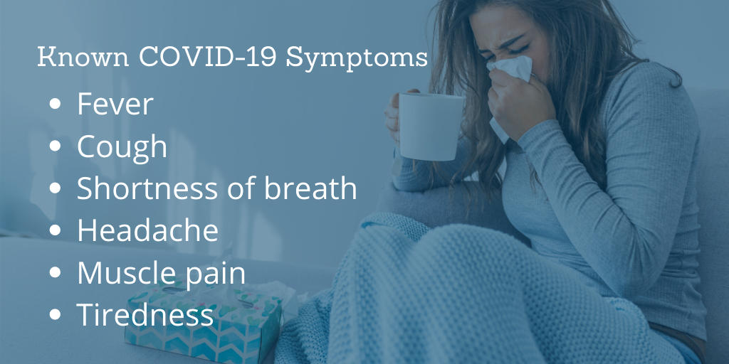

Post 2: Handwashing
Twitter
Washing your hands is simple and one of the most effective ways to prevent the spread of #COVID19. Clean hands can stop germs from spreading from one person to another and throughout an entire community. To learn more about virus prevention, visit the @MichiganHHS COVID-19 webpage ➡ https://bit.ly/2VMsMIV

Facebook
Washing your hands is simple and one of the most effective ways to prevent the spread of novel coronavirus 2019 (COVID-19). Clean hands can stop germs from spreading from one person to another and throughout an entire community. If soap and water are not available, use a hand sanitizer with at least 60% alcohol. To learn more about virus prevention, visit the @Michigan Department of Health and Human Services COVID-19 webpage. https://bit.ly/2VMsMIV

Graphic
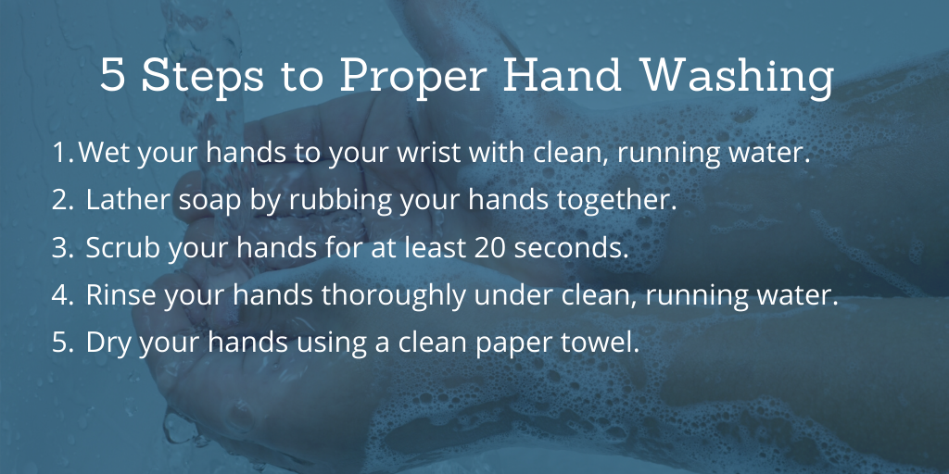

Post 3: Transmission
Twitter
#COVID19 is believed to spread among people who are in close contact with one another through respiratory droplets produced when an infected person coughs or sneezes. To learn more about how COVID-19 is transmitted, visit the @MichiganHHS webpage ➡ https://bit.ly/2VMsMIV

Facebook
Novel coronavirus 2019 (COVID-19) is believed to spread among people who are in close contact with one another through respiratory droplets produced when an infected person coughs or sneezes. It also may be possible that a person can get coronavirus by touching a surface or object that has the virus on it and then touching their mouth, nose or possibly their eyes. To learn more about how coronavirus is transmitted, visit the @Michigan Department of Health and Human Services COVID-19 webpage. https://bit.ly/2VMsMIV

Graphic

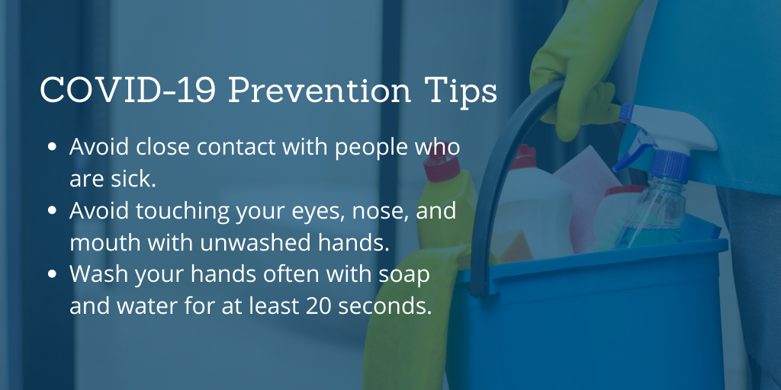
Post 4: Additional Prevention
Twitter
There is currently no vaccine to prevent #COVID19. However, people can help protect themselves from COVID-19 with everyday preventive actions such as washing their hands. To learn more about virus prevention, visit the @MichiganHHS COVID-19 webpage ➡ https://bit.ly/2VMsMIV

Facebook
There is currently no vaccine to prevent novel coronavirus 2019. However, people can help protect themselves from the virus with everyday preventive actions such as washing their hands. To learn more about virus prevention, visit the @Michigan Department of Health and Human Services COVID-19 webpage. https://bit.ly/2VMsMIV

Graphic
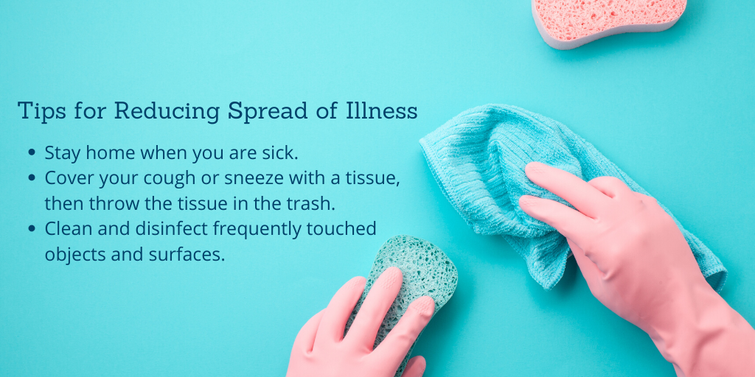
Post 5: Flatten the Curve
Twitter
Working to #FlattenTheCurve will help delay the surge of #COVID19 patients and gives hospitals time to prepare and manage new cases that come in. To learn more about slowing the spread, visit the @MichiganHHS COVID-19 webpage ➡ https://bit.ly/2VMsMIV

Facebook
Working to #FlattenTheCurve will help delay the surge of #COVID19 patients and gives hospitals time to prepare and manage for new cases that come in. To learn more about slowing the spread, visit the @Michigan Department of Health and Human Services COVID-19 webpage ➡ https://bit.ly/2VMsMIV

Graphic
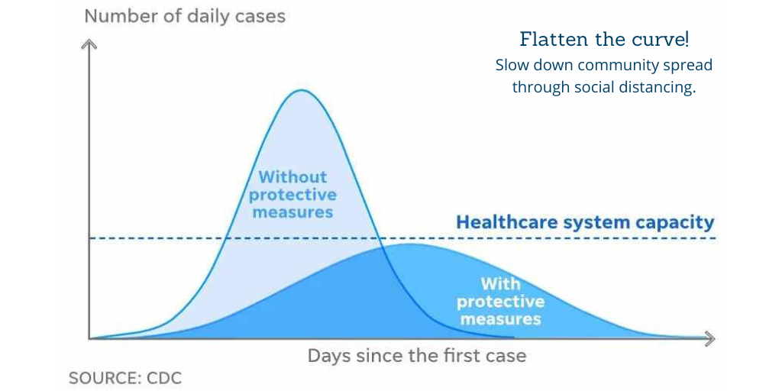
Post 6: Scammer Alert
Twitter
The @MIAttyGen has announced that scammers are contacting MI residents pretending to be from local health departments asking for Medicare and Medicaid numbers. Never provide info over the phone unless you have independently verified the caller as a legitimate source. #COVID19

Facebook
The @Michigan Department of Attorney General has announced that scammers are contacting MI residents pretending to be from local health departments asking for Medicare and Medicaid numbers. Never provide info over the phone unless you have independently verified the caller as a legitimate source.

Graphic

Post 7: Contact your Doctor
Twitter
In a continued effort to flatten the curve, call your doctor before visiting a hospital if you are showing any symptoms of COVID-19. To learn more about slowing the spread, visit the @MichiganHHS COVID-19 webpage.➡https://bit.ly/2VMsMIV

Facebook
In a continued effort to flatten the curve, call your doctor before visiting a hospital if you are showing any symptoms of COVID-19. To learn more about slowing the spread, visit the @Michigan Department of Health and Human Services COVID-19 webpage.➡https://bit.ly/2VMsMIV

Graphic
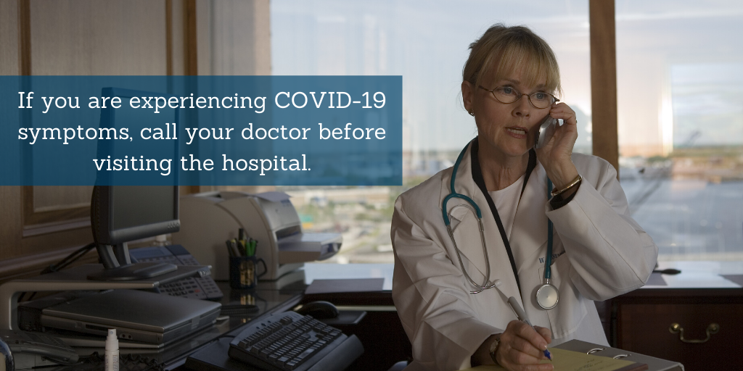

Post 8: Guidelines for Ending Quarantine
Twitter
If you had #COVID19 and will not have a test to see if you are still contagious, only leave your home when you can meet all guidelines for ending your quarantine. If you do not believe you have had the virus, it is highly recommended to stay home regardless to slow the spread.

Facebook
If you had COVID-19 and will not have a test to see if you are still contagious, only leave your home when you can meet all guidelines for ending your quarantine. If you do not believe you have had the virus, it is highly recommended to stay home regardless to slow the spread.

Graphic
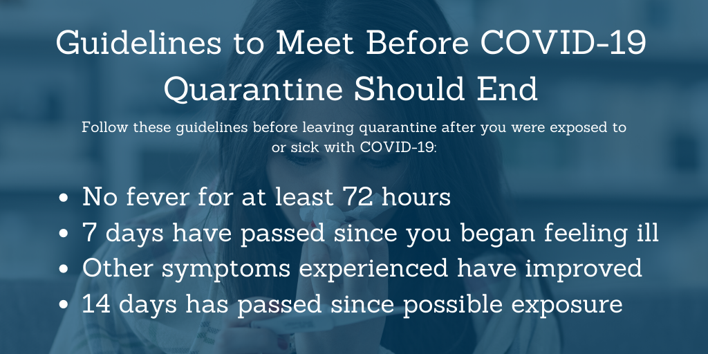

Post 9: When to Seek Help
Twitter
If you are mildly sick and suspect you might have #COVID19, it is important for you to stay home and treat your symptoms. If you are seriously ill, contact your doctor, who will determine how to best treat you and whether you need testing.

Facebook
If you are mildly sick and suspect you might have COVID-19, it is important for you to stay home and treat your symptoms. If you are seriously ill, contact your doctor, who will determine how to best treat you and whether you need testing.

Graphic
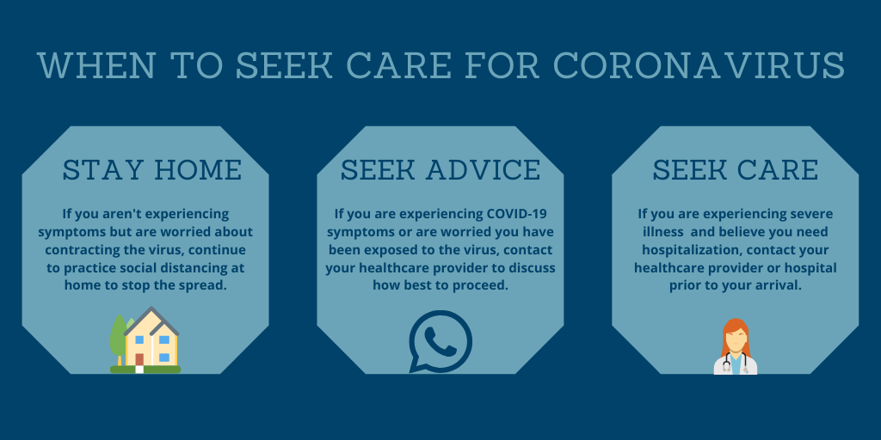

Frequently Asked Questions:

Q: How is the virus spread?
A: The virus is thought to spread mainly from person-to-person through respiratory droplets produced when an infected person coughs or sneezes. These droplets can land in the mouths or noses of people who are nearby or possibly be inhaled into the lungs. It may be possible that a person can get COVID-19 by touching a surface or object that has the virus on it and then touching their own mouth, nose, or possibly their eyes, but this is not thought to be the main way the virus spreads. Some spread might be possible before people show symptoms; there have been reports of this occurring with this new coronavirus, but this is not thought to be the main way the virus spreads.
Q: How do we protect ourselves if we must leave our homes?
A: The best way to prevent illness is to avoid being exposed to this virus. If you must leave your homes, follow these guidelines from the CDC:
- Clean your hands often
  - Wash your hands often with soap and water for at least 20 seconds, especially after you have been in a public place, or after blowing your nose, coughing or sneezing.
  - If soap and water are not readily available, use a hand sanitizer that contains at least 60% alcohol. Cover all surfaces of your hands and rub them together until they feel dry.
  - Avoid touching your eyes, nose and mouth with unwashed hands.
- Avoid close contact with people who are sick

Q: What should I do if I’m symptomatic (cough, fever, difficulty breathing) and suspect I may have been exposed to COVID-19?
A: Contact your doctor if you have symptoms such as fever, cough or difficulty breathing and have been in close contact with a person who has COVID-19, or if you live in or have recently traveled from an area with existing cases of COVID-19. Your healthcare provider will work with the local health department to determine if you need to be tested for COVID-19. They will also provide you with guidance for how to manage your visit to their office and what precautions you should take to avoid infecting others. If possible, virtual or telehealth visits should be used to avoid spreading the virus. If in-person care is necessary, the office may advise you to wear a surgical mask if you have one, wait in your vehicle/outside to be transported into the facility away from other patients, or take other precautions.

Q: Are there enough tests?
A: We are experiencing a national shortage on supplies required to compete COVID-19 testing, so we cannot test every person who is sick. The state of Michigan is working with labs across the state to ensure tests are completed for high-risk individuals and those who may pose a risk of spreading the illness to the public.
Q: Who gets tested for COVID-19?
A: The CDC has issued guidance to healthcare providers for determining which patients likely need testing. Providers will use their judgement of a patient’s symptoms, travel history and risk factors to evaluate a patient. The provider will then contact the state of Michigan to confirm whether the patient meets the High Priority Criteria for testing and , as applicable, execute the testing process.

Q: For individuals who qualify for testing, where can they go to be tested for COVID-19?
A: If you are concerned about your health and experiencing respiratory illness or other concerning symptoms, contact your healthcare provider to discuss your symptoms. Your doctor will make decisions about testing based on signs and symptoms of respiratory illness and potential exposure. They also try to rule out other causes for respiratory illness. If you do not have a doctor, you can call the state’s public COVID-19 hotline from 8 a.m. to 5 p.m. at (888) 535-6136 or call your local hospital. It is important to call ahead before going to any medical facility if you suspect you have COVID-19. We are also asking people to avoid going to the hospital unless they really need to be there as we respond to this outbreak.

Q: Does everyone who suspects COVID-19 need medical treatment?
A: No. Most cases diagnosed thus far around the world have been mild or completely without symptoms and may be cared for by staying home and using comfort care, similar to how you would treat a cold: fluids, rest and over-the-counter medications. Hospitals will focus on caring for those who have more severe cases of the virus, such as populations with underlying health issues that put them at greater risk.

Q: Will my insurer cover treatments for COVID-19?
A: Whether you have private insurance, Medicaid or Medicare, your insurance should cover treatments/care for COVID-19 just as if the care were for any other respiratory illness. In early April, many insurers announced they will cover COVID-19 testing and treatment without any cost sharing for the patient. If you have questions about your cost sharing responsibilities, contact your insurer.

Q: Where is the best source of up-to-date information about COVID-19?
A: For residents and providers in Michigan, the MDHHS website is the best place to start, as it contains both Michigan-specific information and the CDC’s guidance for the public and healthcare providers. You can visit the site at https://www.michigan.gov/coronavirus.

Q: When will a vaccine become available?
A: Researchers are working to develop a COVID-19 vaccine, but that process will likely take 12-18 months. The U.S. Congress is working to ensure that the vaccine will be widely available and that it’s covered by insurers or made available at low or no cost.

Q: How will COVID-19 impact day-to-day living?
A: The stay home order in Michigan is challenging for many people, but following these guidelines is critical to mitigate the spread of the illness. We hope that everyone can take extra precautions to prevent the spread of this virus and keep themselves and their families safe.

Health System Compartment Hardening for COVID-19

In addition to the existing hospital preparation guidance issued by the CDC (https://www.cdc.gov/coronavirus/2019-ncov/downloads/hospital-preparedness-checklist.pdf), hospitals can take additional steps to effectively prepare for a local outbreak. Hospitals should work to harden the three main compartments of care: patients, facility and staff. By combining these measures with other nonpharmaceutical interventions in the community (social distancing, school closures, etc.), we can help to reduce local impact and create resilience.
Patient hardening – Create more resilient patients insulated from risk of transmission (especially the elderly and those with underlying comorbidities such as heart, lung, kidney disease; diabetes, etc.). Possible actions include:
- Provide additional prescription medications for a two- to three-month supply when possible; work to eliminate co-pay penalties and insurance restrictions for longer supplies.
- Use mail-order or other remote refill mechanisms for patients who cannot get longer supplies and who don’t require an in-person visit.
- Under an Executive Order issued March 20, any elective surgeries and procedures must be postponed. For purposes of this order, “non-essential procedure” means a medical or dental procedure that is not necessary to address a medical emergency or to preserve the health and safety of a patient, as determined by a licensed medical provider.
- Ensure patients and staff are up-to-date on vaccines.
- Strengthen internet and telehealth communications between patients and providers so patients can get advice and care while remaining at home, e.g. nurse advice lines, apps and web-based portals.
- Augment home health services for most vulnerable and fragile.
- Facilitate disease-specific social network and support groups where healthcare providers and experienced patients can share lessons, insight and support.
- Engage family members and social support systems to prepare vulnerable patients to shelter in place for one to two months.

Facility hardening – To ensure the continued functioning of the healthcare system, protect patients and staff from nosocomial spread and absorb a large surge of severe respiratory disease, hospitals and other healthcare facilities should act now. Skilled nursing facilities (SNFs), dialysis clinics, cardiac rehab, and other facilities with high concentrations of especially vulnerable patients should make special preparations. Possible actions include:
- Outpatient clinics, ERs and acute-care clinics should initiate parallel/separated triage lines for influenza-like illness (ILI)/upper respiratory infection (URI) patients who do not cross streams with non-ILI/URI.
- Admission screening should occur for all nonacute infectious disease admissions.
- URI/ILI should be identified and either cared for at a remote site for nonserious cases or cohorted in separate area with dedicated staff. Suspected cases of COVID-19 that meet Michigan’s High Priority Criteria for COVID-19 testing should be handled by contacting the statewide testing referral hotline (888-277-9894) to obtain a PUI (person under investigation) number and proceed with sampling.
- Hospitals, clinics, etc. should work with state/local public health labs, commercial labs and academic reference labs to get testing protocols in place as diagnostic availability increases.
- Ward cohorting should start as soon as possible; admissions with pneumonia should be cohorted with dedicated wards and staff that do not mix.
- Outpatient practices should consider engaging home visit/home care options starting now to defer visits.
- ERs and outpatient clinics should engage telehealth resources for acute issue triage, follow-ups, med refills, etc. to defer visits to clinics or ERs.
- Facilities should start expanding inventories of all major drugs and consumables supply stocks to be able to absorb interruptions of supply chain, but avoid hoarding.
- Arrange alternate suppliers for critical supplies in case of shortages.
- Renovation/construction projects that may interrupt workflow or space capacity should be delayed or adjusted.
- Put in place, as appropriate, the conserve/reuse/recycle approach for critical supplies such as PPE.
- Strengthen tele-education and tele-ICU arrangements so ICUs can get remote help and support when overwhelmed. Work to identify remote providers now and practice systems.
- Develop alternate sites of care for hospital ward expansion, including on- and off-site options with surge five to 10 times the normal number of pneumonia and influenza admissions at peak flu season.
- Engage private sector partners to assist in supply and logistics chain strengthening/back-up, transportation, communication, surge space and other critical needs.
- Consider enhanced EMS/paramedic scope of practice for remote case management.

Staff hardening – Health systems depend on staff who are healthy, unconstrained by home needs, illness or economic burden, and confident of their skills and safety while at work. Healthcare employers should attempt to do the following:
- Address personal medical conditions of healthcare staff and provide two- to three-month supply of medications.
- Address family member medical issues and medication supply to avoid staff distraction.
- Assess family support resources that should be made available for planning – elder care, child care, dog walking, and family meals for lower income employees and help facilitate these services.
- Hire and train additional staff if possible; engage locums tenens vendors and travel nurses to supplement ward staff if necessary.
- Academic medical centers should work to provide additional training for medical, nursing and allied health students to provide care and support hospital key functions.
- Coordinate with regional partners and assemble volunteer staff lists of retirees, non-practicing, and other healthcare professionals.
- Accelerate education and training for appropriate Infection Prevention and Control (IPC) practices and PPE use.
- Examine options for rotating blocks of staff.

