COVID-19 Vaccine Social Media Posts
- Johnson & Johnson Vaccine Safety/Efficacy
- Vaccine Eligibility
- Spring Travel Guidance
- Vaccine Hospital Protocol
- Masking Post-Vaccine
- Seniors Vaccine Support
- Vaccine FYIs
- Vaccine FAQs

Johnson & Johnson Vaccine Safety/Efficacy –
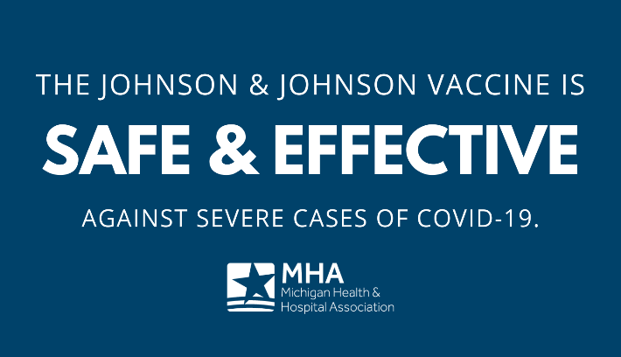
Graphic 1: The safe & effective single-dose @JNJNews COVID-19 vaccine will help us vaccinate our residents more quickly, especially those who are vulnerable and harder to reach. Learn more from the @CDC: https://bit.ly/3qeIhos.

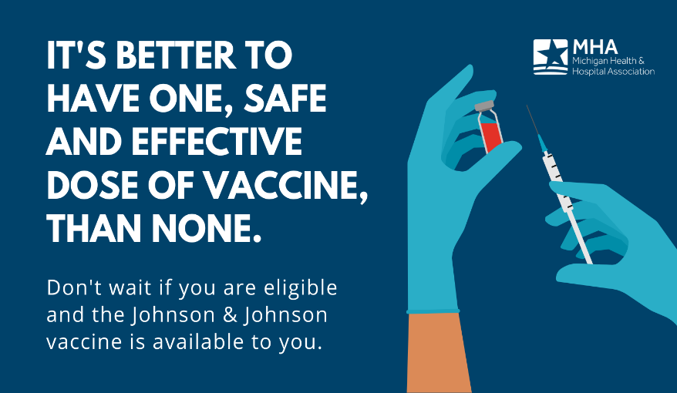
Graphic 2: In clinical trials, the @JNJNews vaccine demonstrated complete protection against COVID-19-related hospitalization and death. If you’re eligible and have access to this vaccine, don’t wait to protect yourself from the virus. Learn more from the @CDC: https://bit.ly/3qeIhos.

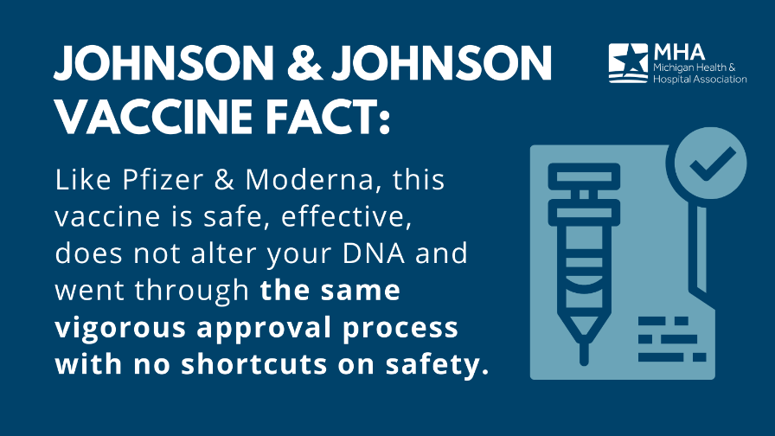
Graphic 3: The @JNJNews vaccine delivers instructions to our cells to trigger the production of antibodies, which results in an immune response to the COVID-19 virus. This single-dose vaccine is safe and effective. Learn more: https://bit.ly/3qeIhos.

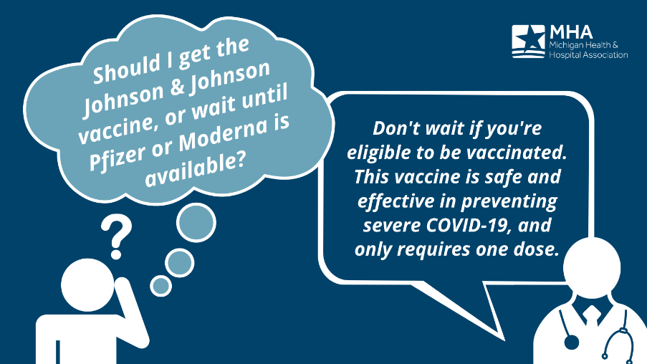
Graphic 4: As we learn more about new variants of #COVID19, health experts are urging those who are eligible to get vaccinated as soon as possible. Learn more about the safe and effective @JNJNews vaccine here: https://bit.ly/3qeIhos.

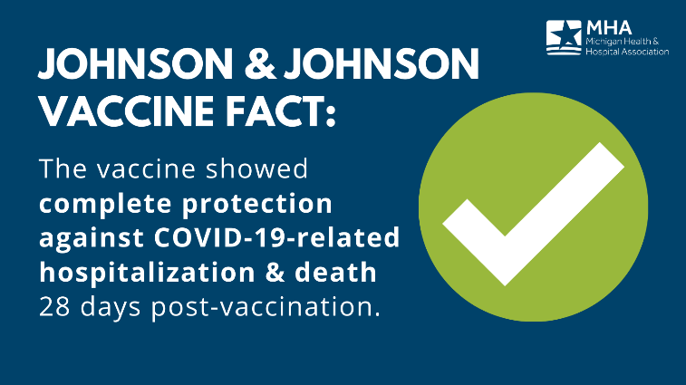
Graphic 5: Like Pfizer and Moderna, the @jnj vaccine it is safe, effective and poses no threat of causing illness or changing your DNA. Learn more: https://bit.ly/3qeIhos.

Vaccine Eligibility –
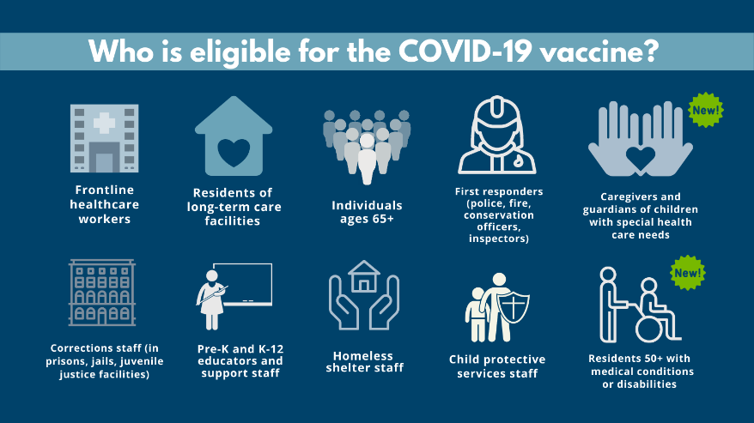
Graphic 1: The @MichiganHHS has expanded #COVID19 vaccine eligibility in our state. Learn more: https://bit.ly/2Ol2Kel

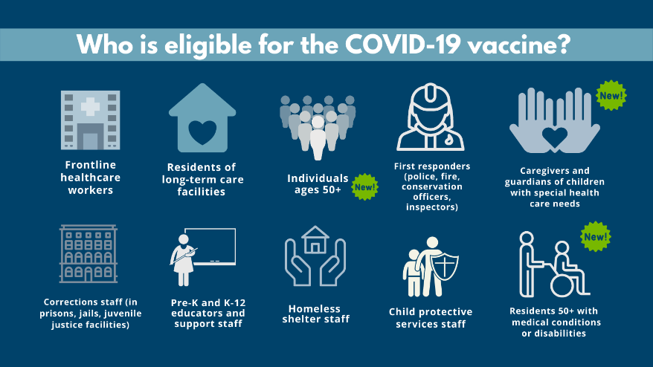
Graphic 2: As of March 22, individuals 50+ are eligible to receive the #COVID19 vaccine in Michigan. Learn more: https://bit.ly/2Ol2Kel

Spring Travel Guidance –
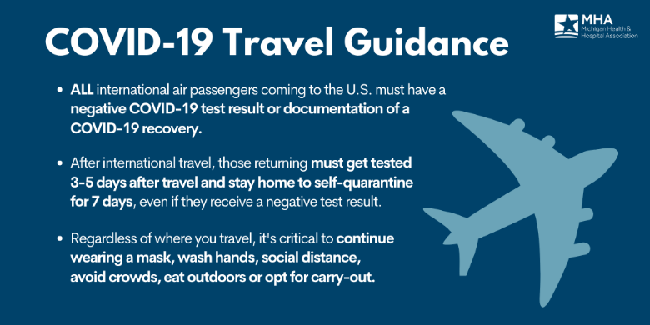
Twitter: Limit travel this Spring season to help protect those who are still vulnerable to COVID-19. Brighter days are ahead.

Facebook/LI: Any Michiganders who plan to travel this Spring season should review COVID-19 travel recommendations from the @CDC, at: https://bit.ly/36VSFrU

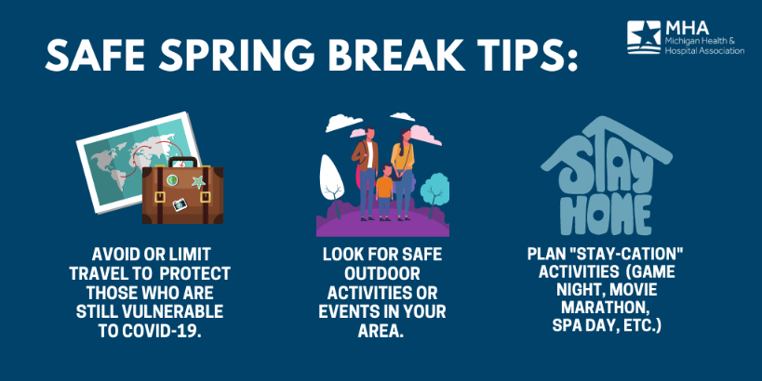
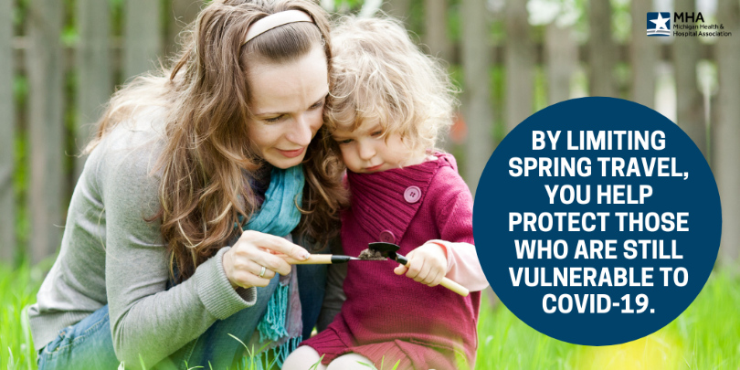

Vaccine Hospital Protocol –
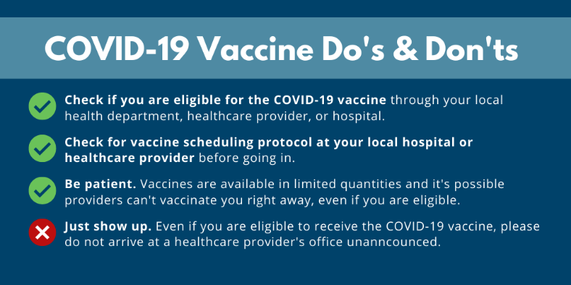
- Graphic 1, Twitter: Local healthcare heroes need your help to ensure vaccinations can continue in a timely, orderly fashion. Keep in mind these #COVID19Vaccine do’s & don’ts:

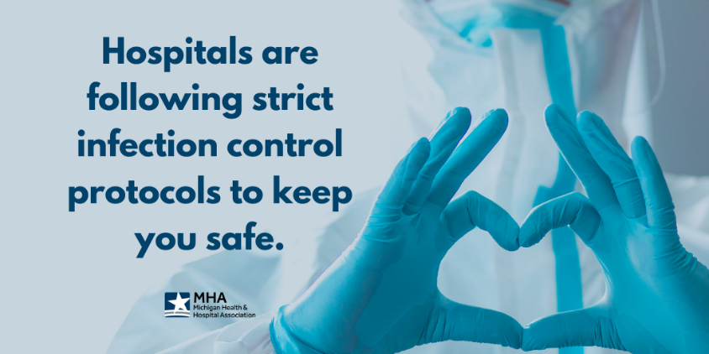
- Graphic 1, Facebook/LI: Administering a vaccine of this scale requires a large amount of resources, coordination and time for hospitals. Help your local healthcare heroes by following the immunization process. To learn more, visit: https://bit.ly/37i0Fqz.

- Graphic 2: Our facilities are a safe place for care whether staff has received the COVID-19 vaccine or not. All healthcare workers are taking extensive safety measures to protect themselves and their patients.

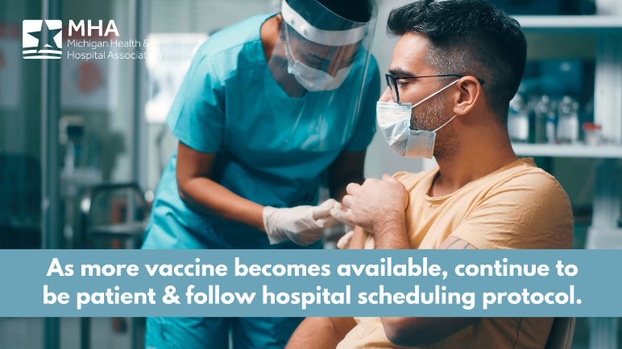
- Graphic 3: Hospitals will continue to be a partner in vaccination efforts, and appreciate your patience and cooperation. Those eligible for a #COVID19 vaccine should call ahead or visit their vaccine provider’s website for scheduling protocol.

Masking Post-Vaccine –
- Twitter: We still have a long way to go before achieving herd immunity from #COVID19, which requires around 70% of the population to be immune. It’s important that you continue masking up – even after getting your vaccine.

- Facebook/LI: Yes, you still need to wear a mask after getting vaccinated. To learn more about why, or get updates on guidance from the @CDC, visit: https://bit.ly/2R9av5m.
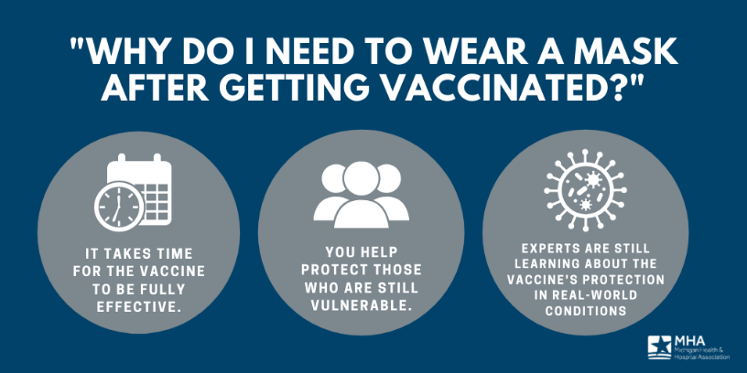
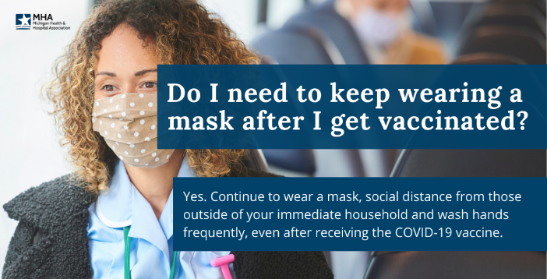

Vaccination Senior Support –
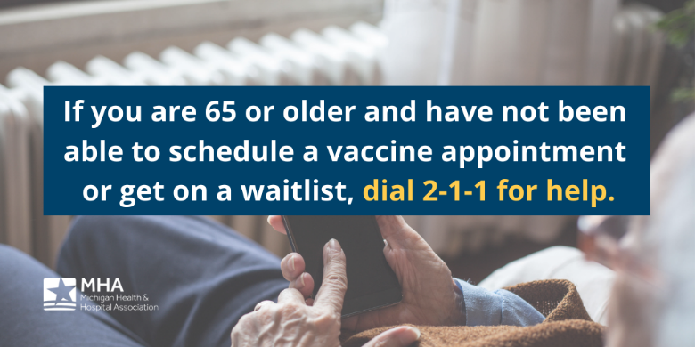
- Twitter: Hospitals are making sure patients who can’t leave home but wish to receive the #COVID19 vaccine can do so safely. If you or a loved one need assistance getting vaccinated, dial 2-1-1 or visit https://www.211.org/.

- Facebook/LI: Our healthcare heroes haven’t forgotten about patients who are homebound but eligible to receive the COVID-19 vaccine. If you or a loved one need assistance with getting vaccinated, dial 2-1-1 or visit https://www.211.org/.

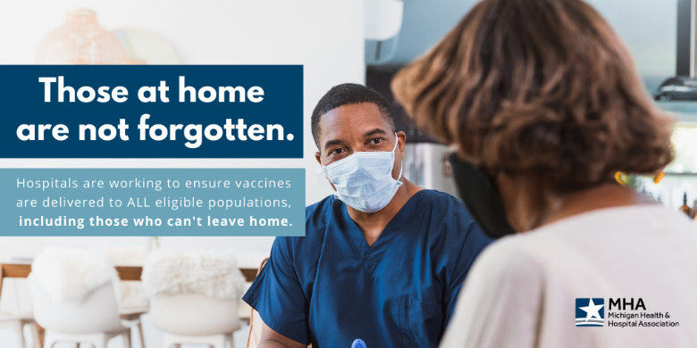
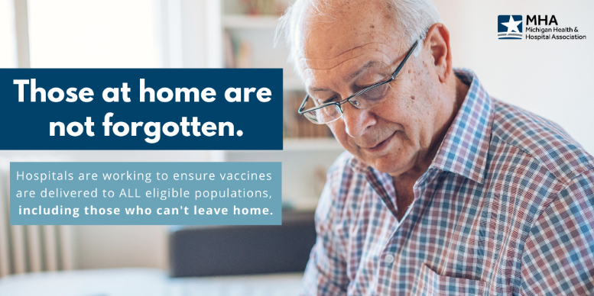

Vaccination FYI’s –
- Graphic 1-4: It’s important to know the facts about the #COVID19 vaccine. Find more answers to frequently asked questions here: https://bit.ly/37i0Fqz.
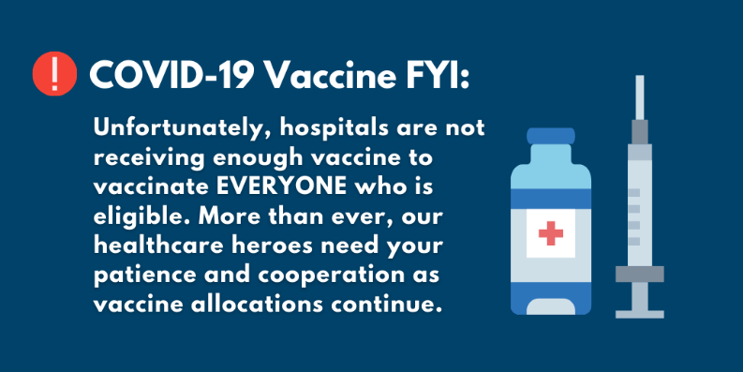
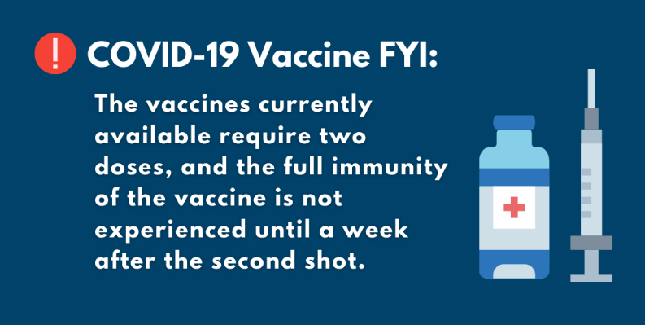

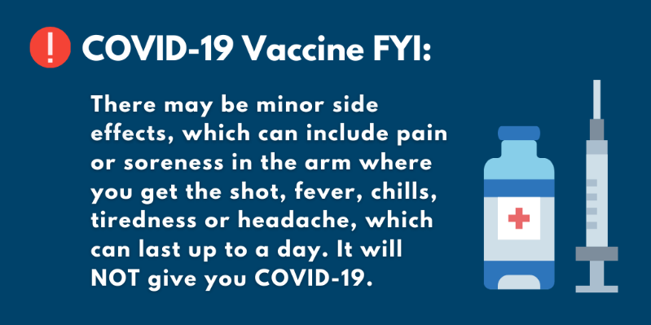
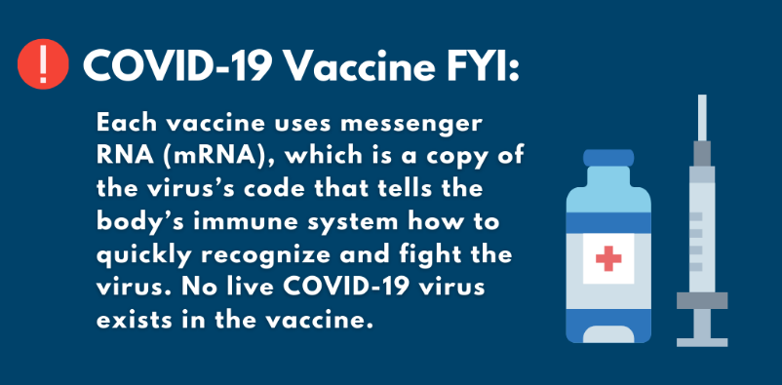

Vaccine FAQ Posts –
- Twitter: Questions about the #COVID19 vaccine? Be sure to seek information from a reliable source. Visit the @CDCgov or @MichiganHHS for more information and answers to frequently asked questions from the experts: Michigan.gov/COVIDVaccine.

- Facebook/LI: Curious about the COVID vaccine’s development, approval or manufacturing process? Be sure to seek information from a reliable source. Answers to frequently asked questions about the vaccine are available by the @CDC and accessible for Michiganders at Michigan.gov/COVIDVaccine.

